Name : Kaustav Ghosh

Reg no 180905188

Roll no 29

Date: 14/12/2020

1)Configure the hosts and the router to conform to the topology shown in Figure 5.2

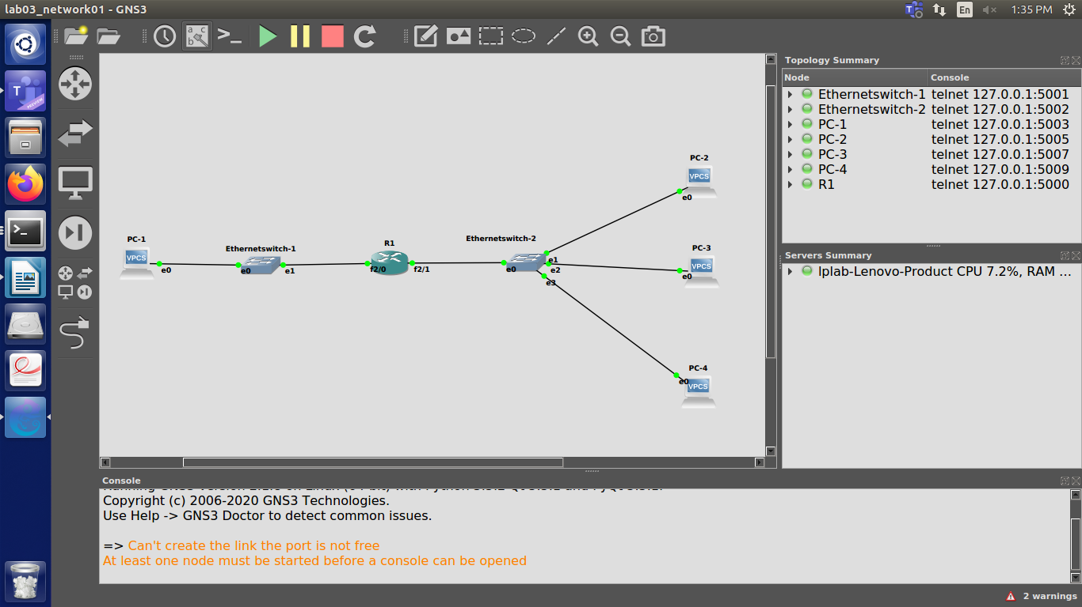

2)Add Router1 as default gateway on all hosts. (PC1, PC2, PC3, andPC4).

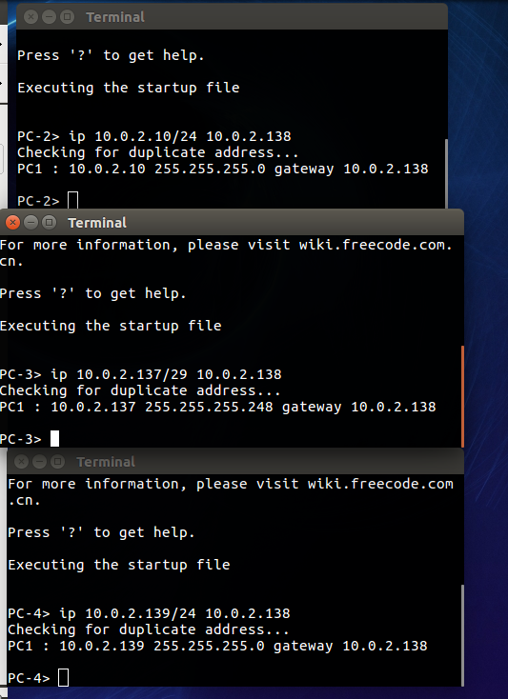

(3) Issue ping commands from PC1

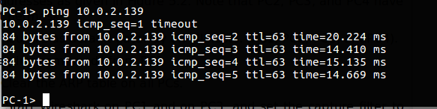

i) Clear the ARP table on all Pcs.

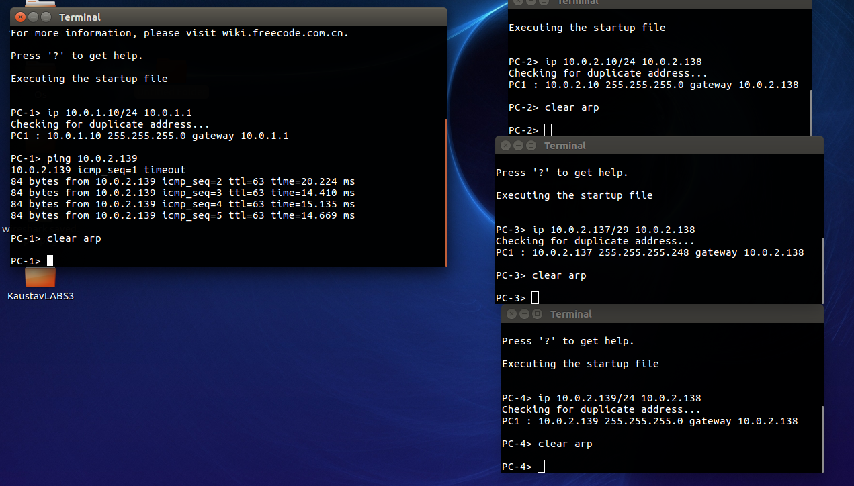

ii) Start Wireshark on PC1 and on PC3, and set the capture filter to capture ICMP and

ARP packets only.

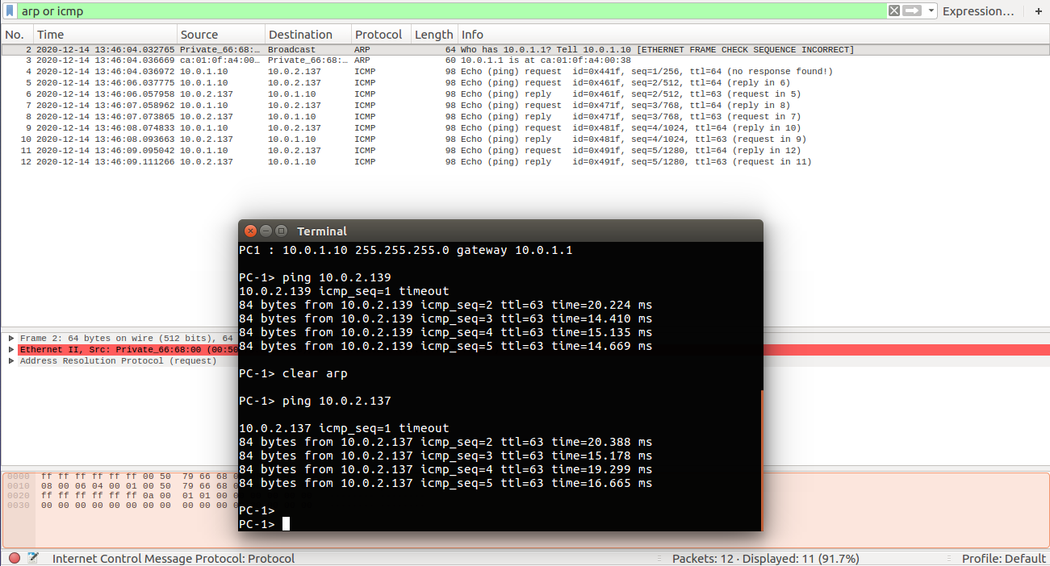

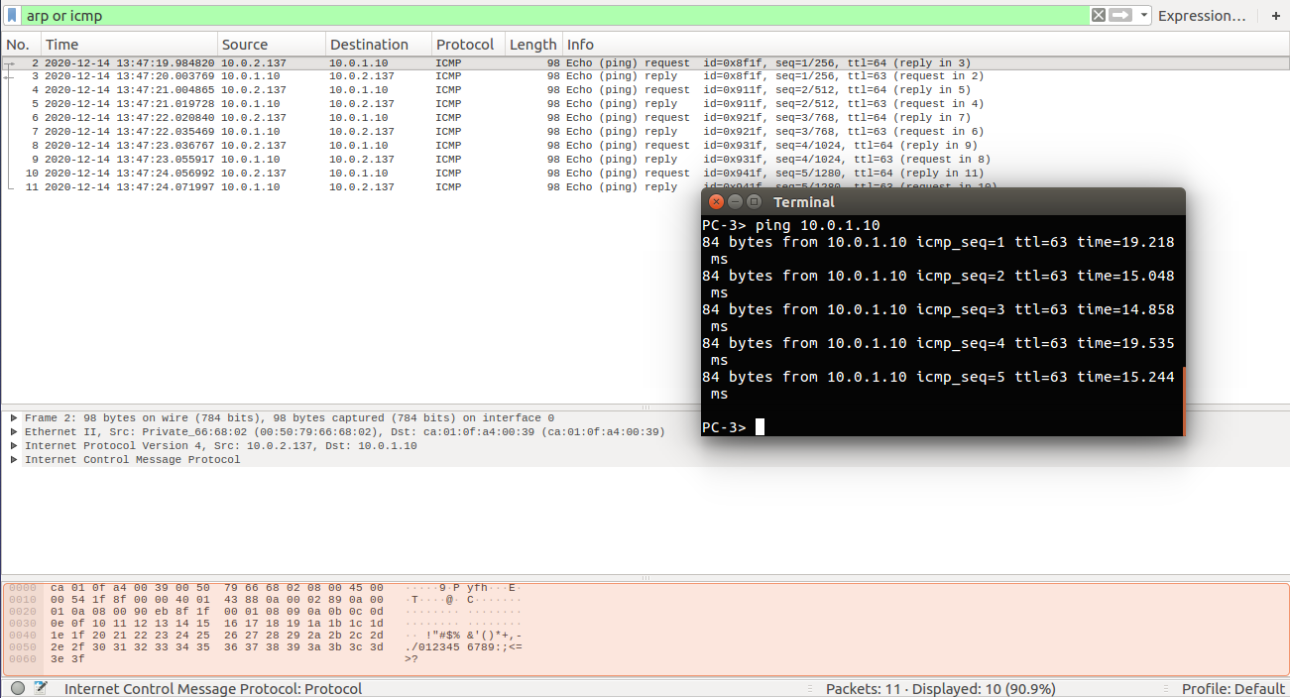iii) Issue a ping command from PC1 to PC3 for at least two sends (-c2).

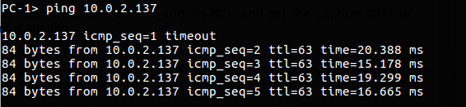

iv)Save the output of the ping command at PC1 and the output of Wireshark on PC1

and PC3.





(4) Save the ARP tables, routing tables, and routing caches of each host.

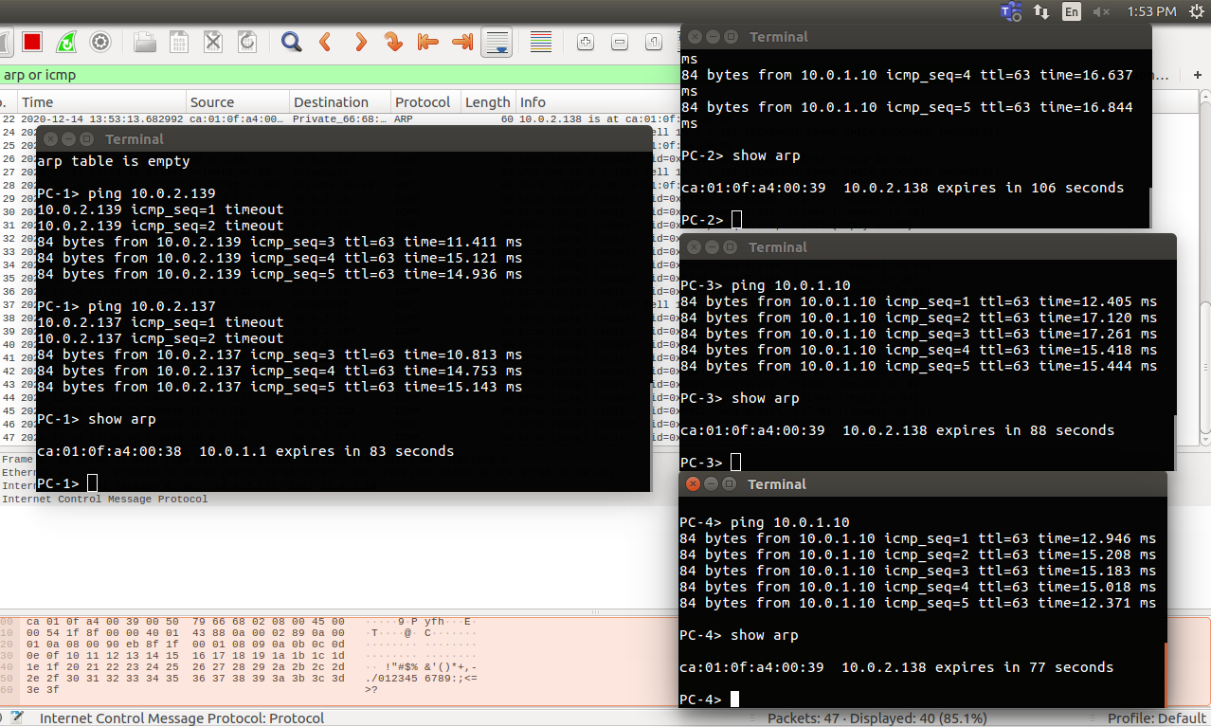

(5) Issue ping commands from PC3 toPC4

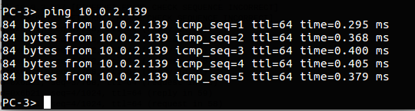

i) Clear the ARP table on all Pcs.



ii) Start Wireshark on PC3, and set the capture filter to capture ICMP and ARP packets

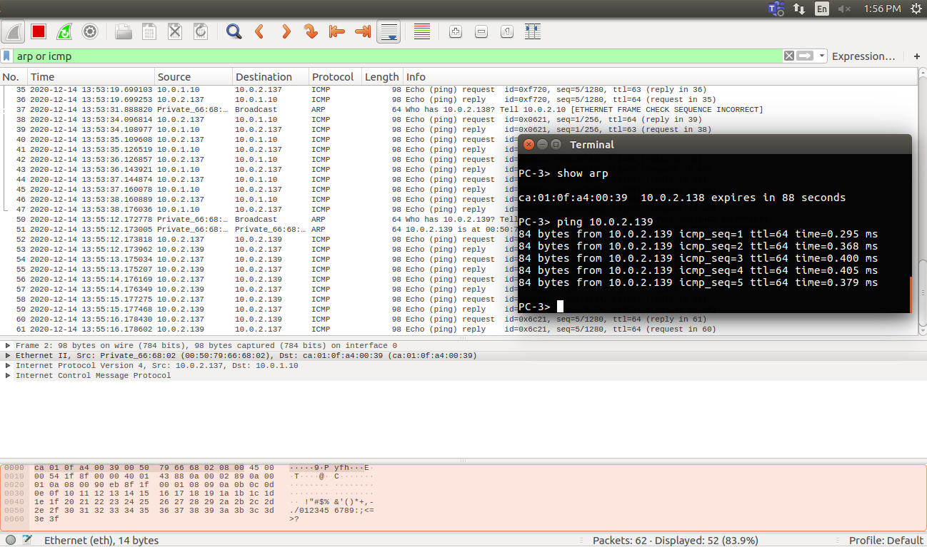 only.

iii) Check the ARP table, routing table, and routing cache of each host.

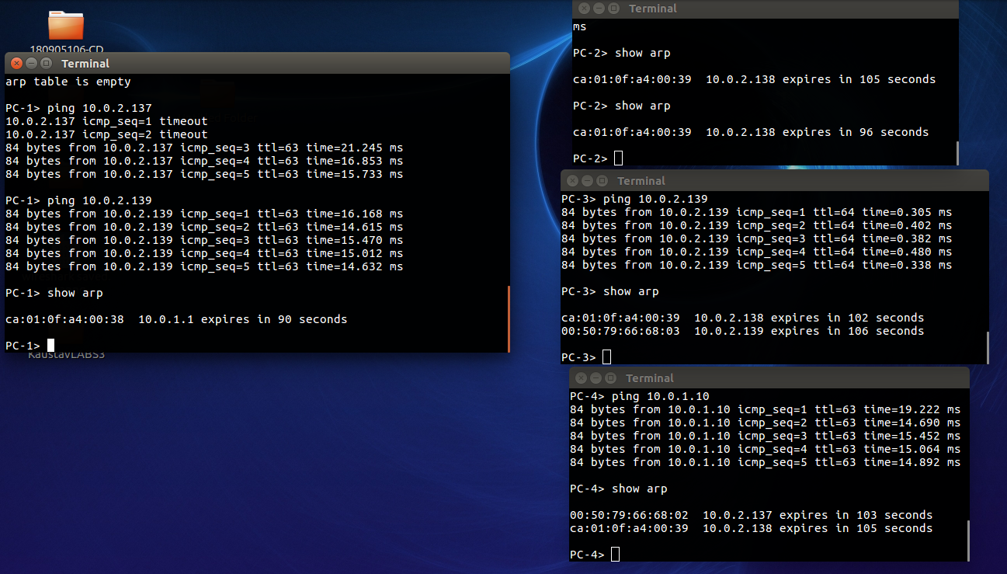

Issue a ping command from PC3 to PC4 for at least three sends (-c 3). Save the output of the ping command and the output of Wireshark on PC3. Save the ARP table, routing table, and routing cache of PC3. Please note that these are the table entries from Step 4 after the ping commands are issued.

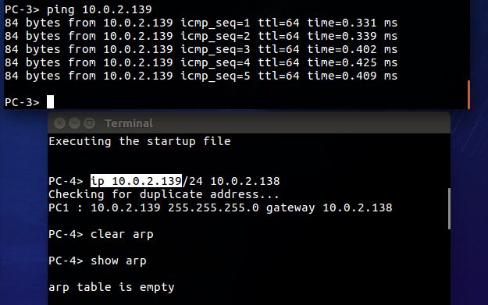

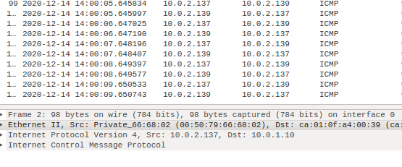

* Repeat Step 4, but this time issues a ping from PC3 to PC2. Note that once an entry is made in the routing cache, you cannot repeat the previous experiment to obtain the same results. You have to wait until the routing cache is reset or you can delete all the routing caches on all devices.



